ASSIGNMENT - VI
Design Patterns in Java

Definition :-
Design Pattern are reusable solutions to Commonly recurring design
problems in software design or software development, offering a structured approach to building robust and maintainable applications.
Key points :-
- It provide a general approach for creating objects and structuring code in a way that enhances flexibility, maintainability and scalability.
- Design patterns enhance the code readability and help to manage the software complexity.
- Mainly Design patterns are three types. They are :
- Creational Patterns
- Structural patterns
- Behavioural patterns
- Using the design patterns facilitates better collaboration among the developers through a shared terminology.
Types of Design pattern :-
In the Design patterns mainly three types of Design patterns.
They are :
- Creational design pattern
- Structural pattern
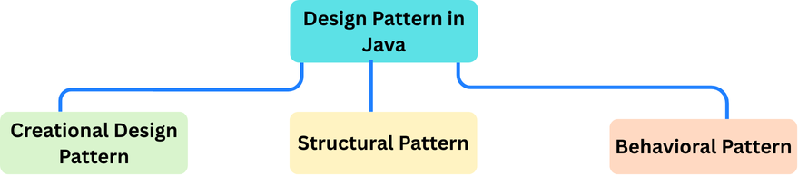
- Behavioral pattern

- Creational Design Patterns :-
- The creational design pattern are focus on object creation mechanisms, providing flexibility and reuse while abstracting the instantiation process.
- The creational design pattern catgeriozed total 5 types. They are :

- Singleton method design pattern
- Factory method design pattern
- Abstract factory method design pattern
- Builder method design pattern
- Prototype method design pattern

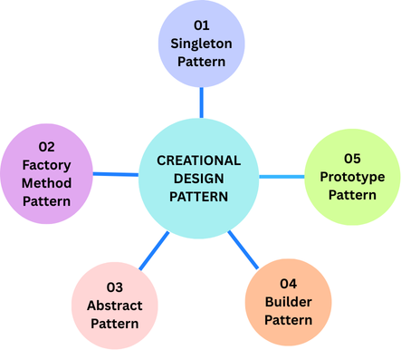

- Singleton method design pattern :-

- Ensures a class has only one instance and provides a global point of access to it.
- It is useful for cases like logging, configuration, or managing shared resources.
- Factory method design pattern :-

It provides an interface for creating objects in superclass, allowing subclasses to decide which class to instantiate.

- Abstract method design pattern :-
It provides an interface for creating families of related or dependent objects without specifying their concrete classes.

- Builder method design pattern :-
It seperates the construction of a complex object from its representation,
allowing the same construction process to create different representations.
- Prototype method design pattern :-
Creates a new objects by copying an existing object like prototype.

Benfits :-
- Make the system independent of how objects are created and composed.
- Hides class information and installation details.
- Encapsulation of complex creation logic.
- Supports code scalability & flexibility.

- Structural design patterns :-
- This pattern are focus on how classes and objects are composed larger structures while keeping those structures flexible and easy to maintain.
- These patterns simplify the relationships between object and promote the code to reusability
- These are totally 7 types :

- Adapter method design pattern
- Bridge method design pattern
- Composite method design pattern
- Decorator method design pattern
- Façade method design pattern
- Proxy method design pattern
- Fly weight method design pattern

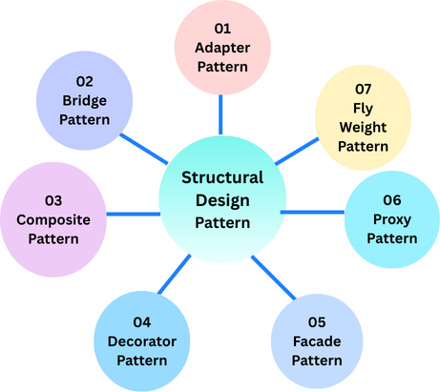

- Adapter method design pattern :-
Converts the interface of a class into another interface clients expect, allowing incompatible interfaces to work together.
- Bridge method design pattern :-
It separates the an abstraction from its implementation, allowing them to vary independently and it is useful for decoupling the implementation.
- Composite method design pattern :-
It can treats individual objects and groups of objects uniformly in tree structure.
- Decorator method design pattern :-
Dynamically adds new responsibilities to object without modifying their code.
- Façade method design pattern :-
It provides aa simplified interface to a complex subsystem.
- Fly weight method design pattern :-
It minimizes memory use by sharing common object data instead of creating duplicates.

- Proxy method design pattern :-
Provides a surrogate or placeholder to control access to another object.
Benfits :-
- Reduce duplicate code and promote to reuse.
- Optimize the memory use with shared object data
- Simplify the code by organizing and connecting objects clearly.

- Behavioral design patterns :-

- Behavioral design pattern are a group of design patterns that focus on how objects and classes interact and communicate with software development.
- They emphasize the collaboration between objects to effectively accomplish tasks and responsibilities, making the system more adaptable.
- In the Behavioral design pattern totally 10 types . They are :

- Observer method design pattern
- Strategy method design pattern
- State method design pattern
- Command method design pattern
- Chain of responsibility
- Template method design pattern
- Interpreter method design pattern
- Visitor method design pattern
- Mediator method design pattern
- Memento method design pattern

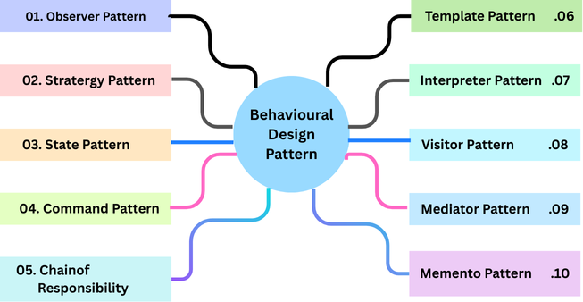

- Observer method design pattern :-
Converts one interface into another to make incompatible classes work together.
- Stratergy method design pattern :-
Decouples abstraction from implementation so they can vary independently.
- State method design pattern :-
Allows an object to change behavior dynamically when its internal state changes.
- Command method design pattern :-
Encapsulates a request as an object to parametrize clients and support undo/redo.
- Chain of responsibility method :-
Passes a request along a chain of handlers until one processes it.
- Template method design pattern :-
Defines the skeleton of an algorithm. Letting subclasses override specific steps.
- Interpreter method design pattern :-
Defines a grammar and provides an interpreter to evaluate language expression.

- Visitor method design pattern :-
Separates algorithms from the objects on which they operate by using a visitor class.
- Mediator method design pattern :-
Centralizes communication between objects to reduce direct dependencies
- Memento method design pattern :-
Captures and restores an objects state without exposing its internals.
Benfits :-
- Improve communication between objects
- Increase flexibility by allowing behavior change without altering code.
- Simple to maintain.

Singleton Design Pattern
Definition :-
- The singleton method design pattern ensures that a class only one instance and provide a global access point to it.
- It is a ideal for scenarios requiring centralized control, like managing the database connections or configuration settings.
Process of Singleton :-
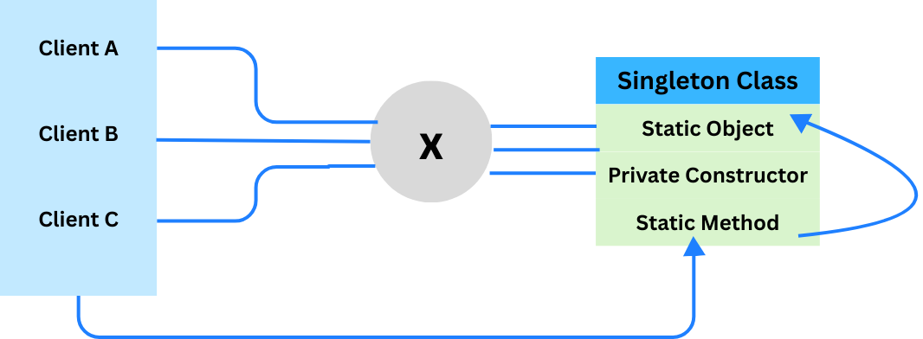

Why the name of Singleton method design :-
- The Singleton name comes for the fundamental purpose To ensure that a class has only one instance, or single instance throughout entire application.
- This design pattern restricts the number of objects created from class, providing controlled centralized access to that single, unique object.
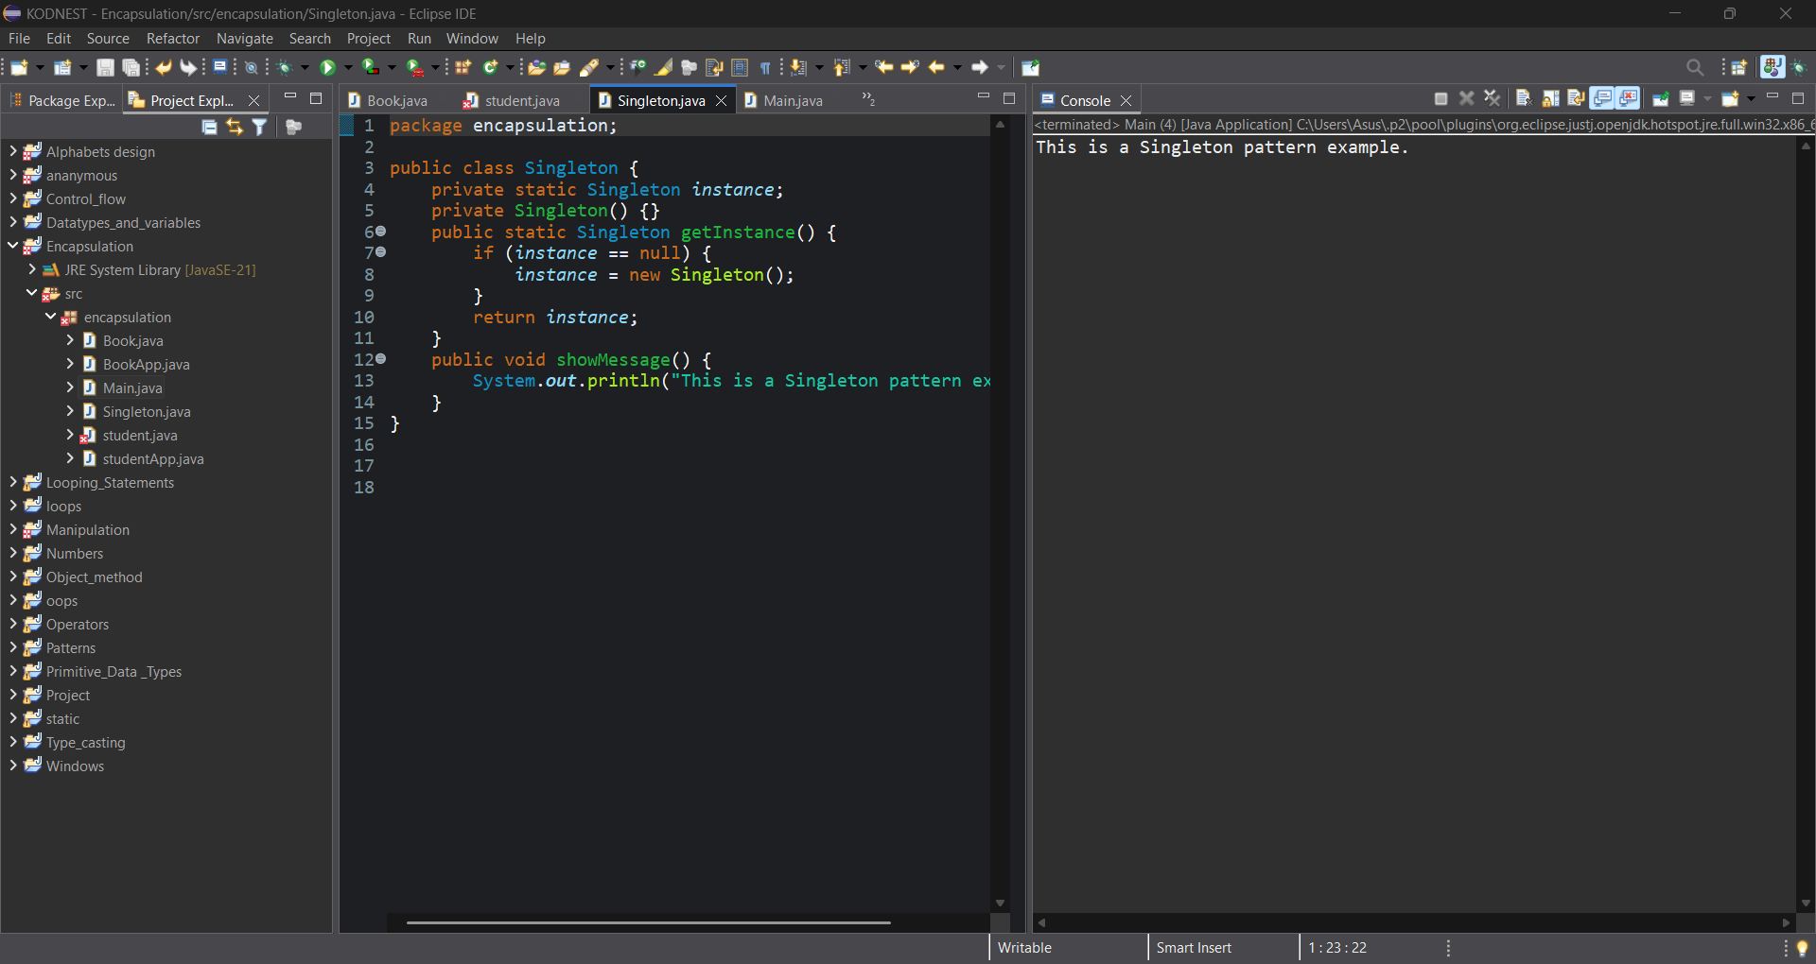
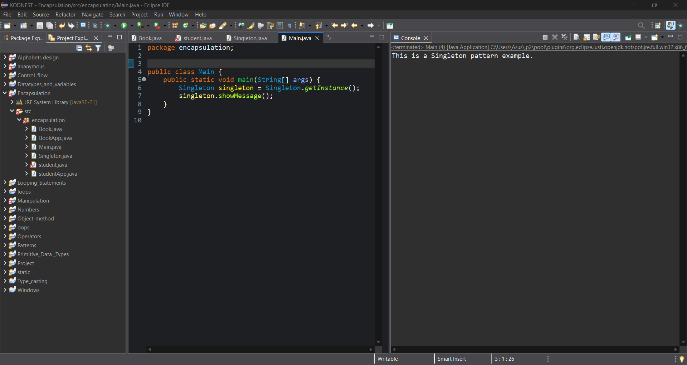
Implementation Example :-

